
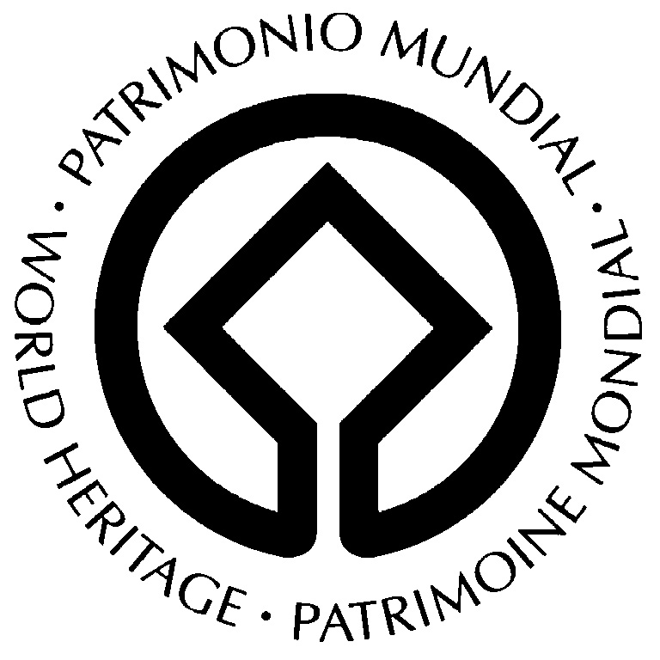
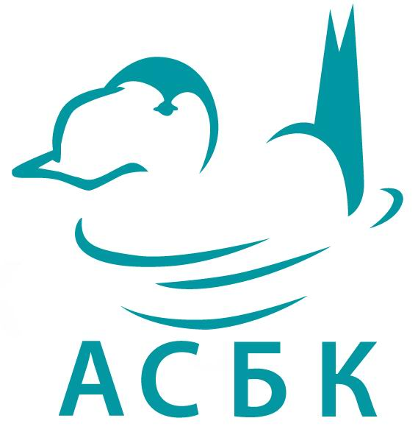

UNESCO Sub-Regional Meeting on the Nomination of the West Tien-Shan
as a Transboundary Natural Heritage Site

18-19 July 2007, Almaty, Kazakhstan

Organizers:
UNESCO Almaty Cluster Office, Association for the Conservation of Biodiversity in Kazakhstan, with the support of the UNESCO World Heritage Centre and UNESCO/Italian Trust Fund for World Heritage.

The international meeting has been attended by 23 participants - representatives of governmental agencies, scientific and public organizations from Kazakhstan, Kyrgyzstan and Uzbekistan, experts from the central and regional UNESCO offices.

Working in the framework of the Global Strategy for a Balanced, Representative and Credible World Heritage List, taking into account recommendations of previous regional UNESCO workshops (“Possibilities of Nominations on World Natural and Mixed Heritage in Central Asia”, Almaty, December 2002; “Sub-regional workshop for the follow-up of the Periodic Reporting Exercise for Central Asia”, Almaty, November 2005), and drawing on international experience regarding preparation of natural transboundary nominations, the participants have developed the following proposals and recommendations:

1. Preparation of the West Tien-Shan nomination

- Taking into consideration the presence within the border area of West Tien-Shan of specially protected areas (SPA) with a high-level protection status - to propose as a WH nomination a transboundary serial site which would include 8 SPAs composed of a total of 12 clusters:
Republic of Kazakhstan: Aksu Zhabaglinsky State Nature Reserve, Sairam-Ugamsky State National Nature Park (3 clusters), Karatausky State Nature Reserve.
Kyrgyz Republic: Sari-Cheleksky State Biosphere Reserve, Besh-Aralsky State Reserve (2 clusters), Padyshatinsky State Reserve and Kara Buurinsky State Reserve.
Republic of Uzbekistan: Chatkalsky State Biosphere Reserve (2 clusters).
- To propose a combination of buffer zones of SPAs comprising the serial site as a Buffer Zone of the nominated transboundary site.
- To initiate the establishment of buffer zones for Besh-Aralsky State Reserve and Kara Buurinsky State Reserve; to complete the creation of buffer zones of Sari-Cheleksky State Biosphere Reserve and Chatkalsky State Biosphere Reserve.
- To revise the Tentative Lists of Kazakhstan, Uzbekistan and Kyrgyzstan in order to include SPAs comprising the West Tien-Shan WH site, with a particular note about their belonging to a transboundary property.
- Taking into account that the nominated area is of high biodiversity, geological, evolutional and aesthetic interest - to nominate the West Tien-Shan natural site under all 4 natural criteria (criteria vii-x).
- To use findings of a GEF/World Bank’s Central Asia Transboundary Biodiversity Conservation project for the preparation of the West Tien-Shan nomination.
- To establish an intergovernmental coordinating committee for the nomination preparation.
- To establish national working groups responsible for the nomination preparation process and to appoint coordinators.
- To develop management-plans for each SPA comprising the nominated property. To provide harmonization at the regional level of management plans for individual SPAs comprising the transboundary site.
- To set the 30th of September 2009 as the date for submission of the West Tien-Shan nomination dossier to the UNESCO WH Center.
- To prepare the nomination in accordance to an activity-plan (see the attachment).
- To submit a list of SPAs which have received recognition from national and international experts and have been proposed for inclusion into the transboundary West Tien-Shan natural site to the Governments of Republics of Kazakhstan, Uzbekistan and Kyrgyzstan. To ask the Governments to provide organizational support to the nomination preparation process including the adoption of necessary decisions and the approval of intergovernmental agreements.

2. Fundraising

- To formulate specific proposals and to incorporate the preparation of the nomination into the GEF/World Bank’s Central Asia Transboundary Biodiversity Conservation project.
- To ask National Commission of Kazakhstan for UNESCO and ISESCO to prepare in collaboration with National Commission of Kyrgyzstan for UNESCO and National Commission of Uzbekistan for UNESCO, the UNESCO Almaty Cluster Office and then submit to the WH Fund a request for preparatory assistance for the West Tien-Shan nomination,.
- To consider the possibility to obtain alternative funding for the nomination preparation (governmental budget financing, Partnerships for Conservation and UNESCO Participation Program , international grants, support from business structures, etc).
- To provide informational support to the project activities (such as publishing articles in periodical press, publishing an informational bulletin, translating and disseminating World Heritage-related literature, designing web-sites for SPAs comprising the nominated property, etc).

Conclusion
- There are currently no WH Sites inscribed for their natural values in a vast Central Asia Region. The area of West Tien-Shan has a high chance of inscription on to the UNESCO World Heritage List. Participants of the meeting confirm the choice of the West Tien-Shan transboundary serial site as a priority candidate from the Central Asia Region.
- Taking into consideration an outstanding value of undisturbed natural landscapes of Central Asia the participants of the meeting recognize the expediency of carrying out studies on compilation of Tentative Lists of natural properties of Central Asian States.
- Participants emphasize important achievements of the GEF/World Bank’s Central Asia Transboundary Biodiversity Conservation project and welcome further activity towards that direction.
- Participants express their gratitude to UNESCO for the support given to help in preparation of the West Tien-Shan transboundary site and hope for further cooperation in identification and conservation of World Natural Heritage in the Central Asia Region.
- The participants express their gratitude to the Association for the Conservation of Biodiversity in Kazakhstan for the high organizational level of the meeting.

