Uvs Nuur Basin,
Mongolian-Russian World Heritage Site

“Elaboration of a Joint Mongolian-Russian Federation Site Management Plan for the “Uvs Nuur Basin” World Heritage Site”

UNESCO Activity-Financing Contract No.: 876884.5

Final Report

Alexey Butorin, Natural Heritage Protection Fund

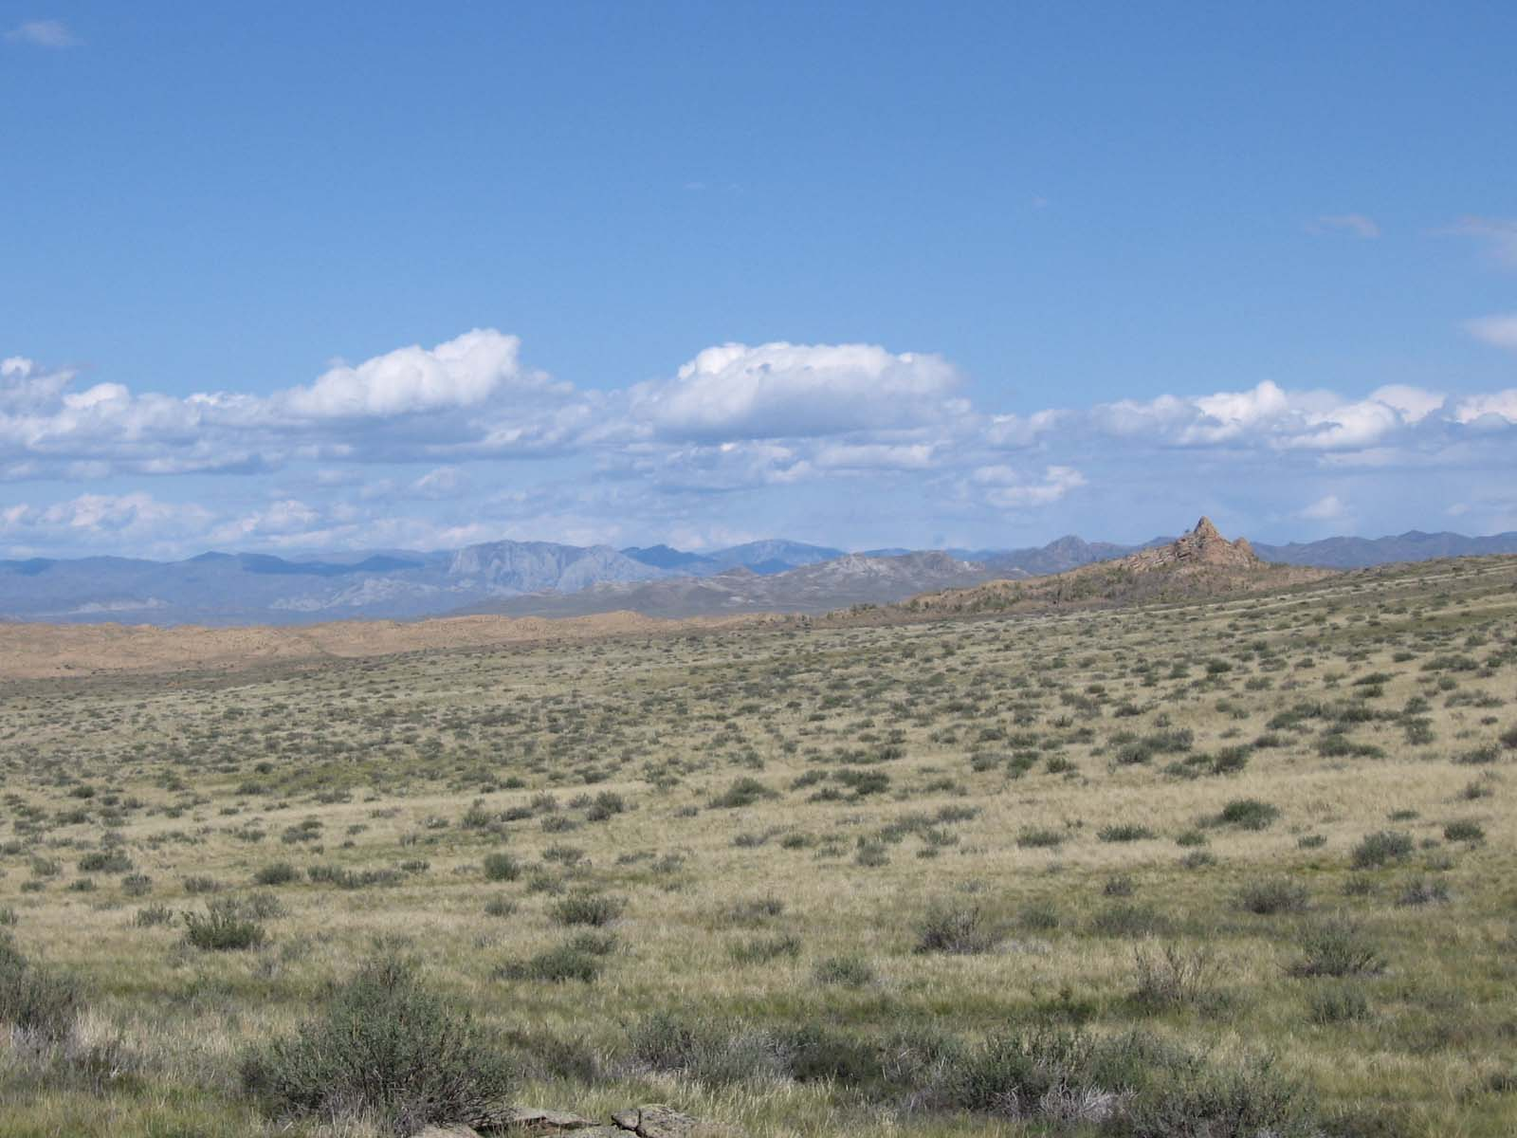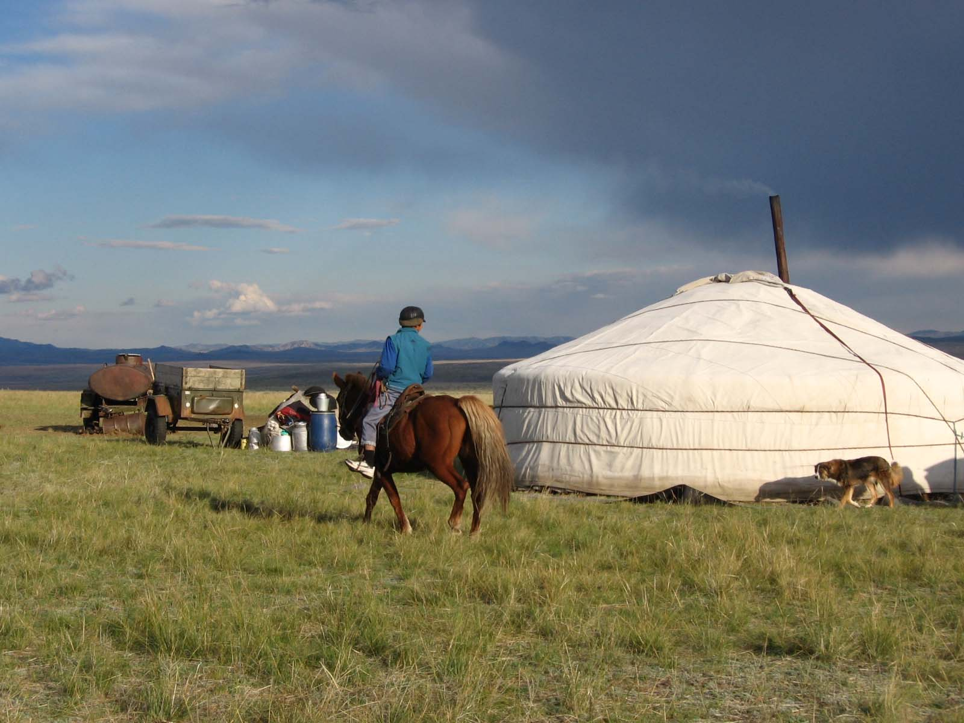
October 2005

Contents

1. | List of accomplished activities | 3
2. | Annex 1. First expert mission report | 3
3. | Annex 2. Second expert mission, National Stakeholders Workshop resolution | 6
4. | Annex 3. Workshop program | 10
5. | Annex 4. Workshop list of participants | 10
6. | Annex 5. Resume of the Project | 11

Within the frames of the project realization there have been organized two expert trips to Kysyl (Tyva Republic) and to the “Ubsunur Hollow” State nature biosphere reserve, which has been inscribed on the UNESCO World Heritage List in 2003.

The aim of the first expert trip, which took place at 8-13 of August was collecting data on the modern state of conservation of the Russian part of the WH site, and also defining a list of administrative bodies, commercial structures, scientific and public organizations interested in cooperation with the reserve. The result of the trip was the report, which included description of the modern state of conservation of the WH site, its management problems and a list of organizations to a greater or lesser extent taking part in the activity of the reserve. During this trip negotiations with heads of these organizations have been carried on, and agreement of their participation in a national meeting concerning management problems of the Russian part of the WH site has been reached and its time constraints have been defined. The key event was the meeting with the First Vice-Chairman of the Tyva Government A.V.Brokert, during which the decision of giving the project the concernment of the republican level has been made. All the following activity within the frames of the project has been coordinated by the Administration of Tyva Republic.
During the trip a field excursion to “Tsugeer Els” and “Yamaalyg” clusters of the reserve has been made for modern WH site conservation state study.

Annex 1
Report on implementation of the 1st stage of the project
«Elaboration of a joint Mongolian – Russian Management Plan for the Uvs Nuur Basin natural site»

The 1st stage of the project was an expert mission to the cities of Kyzyl and Erzin, and Uvs Nuur Hollow Reserve clusters “Tsugeer Els” and “Yamaalyg” (Tuva Republic) from 8 to 13 of August 2005.

During the mission the following meetings have been arranged:

At Governmental level - meeting with A.V. Brokert (Deputy Chairman) and E.V. Kara-Sal (Chief of the Tuva Republic Tourism Agency)
- In the Tuva office of Rosprirodnadzor (Federal Nature Management Inspectorate) - with A.N. Krynitsin (Vice Head of the office)
- In the Erzin Rayon Administration - with A.K. Chombu (Head of the Rayon’s Administration)
- In the Ministry of Natural Resources – with A.D. Dodouk (Director of the Uvs Nuur Hollow Natural Biosphere Reserve)
- In the Republican Ministry of Nature Management – with K.S. Dolgar (Minister)
- In the Uvs Nuur International Center of Biosphere Researches – with S.S. Kurbatskaya (Director of the Center)

The data collected during the mission evidence that the Russian part of the Uvs Nuur Hollow WNH site is preserving in accordance with regulations of the Convention concerning the World Cultural and Natural Heritage and meets the criteria under which the site was inscribed in the UNESCO WH List.
Since the time of inscription of the reserve on the WH List the following important conservancy measures have been fulfilled.
In accordance with the Decree of the Government of Russian Federation #372 of 21.04.2000 and of the Government of Tyva Republic #592 of 30.06.2004 the area of the reserve has been significantly expanded. The total area after the expansion made 601 938 ha. The reserve’s clusters and their buffer zones included into the WH site are located at Erzinsky (Tsugaeer Els, Ular and Yamaalyg clusters), Tes-Khemsky (Oruku-Shinaa, Aryskannyg clusters), Ovjursky (Ubsa-Nuur) and Mongun-Taiginsky (Mongun-Taiga) districts of Tyva Republic. Two clusters (Kara-Khol and Khan-Daeer) area located outside the Ubsunur hollow and are not included into the WH site.
7 State inspections were created at the above clusters. Of these, a mobile field group of 7 people is constantly operating at the reserve itself. Taking into consideration protection system features, geographic location, accessibility and remoteness of some clusters, the inspections are being constantly strengthened and the number of inspectors is being increased. At present moment the total number of inspectors is 41. The work of the protection department is being executed in coordination with present general lines of activity of the reserve and the guidelines of the State policy for development of the system of State nature reserves and national parks of RF until 2015.
The reserve has completed an agreement with the “Uvs-Nuur” Mongolian near-frontier reserve about the execution of common inspector swoops along both sides of the frontier, exchanging field data on violations and fires along the frontier, undertaking of common measures for their liquidation.
The reserve has also completed agreements with the Federal Forestry Agency and local forestries about prevention, suppression and liquidation of forest fires. The common spot-checks are executed and temporary fire-observation station are being created.
Cooperation agreements have also been signed with the Military unit #2061 of Armed Forces of RF, the Tyva custom-house, neighboring with the reserve’s area, local self-governing bodies of districts where the clusters of the reserve are located.
Within the frames of the Association of the Reserves of Altai-Sayan region and under the program of conservation and monitoring of rare and endangered animals (ounce, Marco Polo Sheep and others) the “Ubsunur Hollow” reserve together with Altaisky and Sayano-Shushensky reserves carries out common protective activities.
For the raising of state inspectors’ skills level the reserve carries out annual obligatory inspector training under the specially developed program with participation of leading specialists of nature protection and law-enforcement bodies. For exchanging experience inspectors take part in seminars run by other protected areas. After finishing the studies each inspector has to pass an exam.
State inspectors take part in counting of ungulates in winter and birds in spring time. Counting of the Red Book species at the “Mongun-Taiga” cluster is carried out in cooperation with the Science department of the Altaisky reserve.

Nevertheless there are some factors threatening both to the landscape and biodiversity of the site. They are first of all:
- Pollution of rivers, lakes and the adjoining areas with household rubbish;
- Uncontrolled growth of tourism and alpinism;
- Rise of poaching and illegal fishing (especially during breeding periods);
- Forest and steppe fires;
- Soil pollution with fuel remains of space vehicles at the area of “Kara-Khol” cluster;
- Illegal archeological digs of cultural and historic monuments.

In improving the protection system of natural complexes the reserve encounters the following difficulties:
- The protection service is poorly equipped with modern outfit (especially with means of transport and communication);
- There are no maps with accurate indication of administrative boundary with Krasnoyarsky Krai and Altai and Khakassia Republics for territorial adjudication;
- Local self-governing bodies do not allocate financial means for the control over compliance of sanitary norms in the water-protection zone of rivers and lakes (within buffer zones of the reserve), for maintenance of areas;
- The reserve’s area lacks information signs and panels marking its special regime and the WH status;
- The cooperation between the Reserve’s protection service inspection and the bodies of internal affairs for execution of common poaching control measures has not yet been established.

The talks and consultations held during the mission resulted in specified plan of further activities within the framework of the project. Also the list of stakeholders for the September, 11-15, international seminar dedicated to development of common Mongolian-Russian management plan has been drawn up:
1. Dodouk, Andrian (Drector of the Uvs-Nuur Hollow State Biosphere Reserve).
2. Kynyra, Sergei, Chief of guard department of the Uvs Nuur Holow State Biosphere Reserve.
3. Spitsin, Sergei, a research officer of the Uvs Nuur Hollow.
4. Dorzhu, Oleg, Head of the Tuva office of Rosprirodnadzor.
5. Dolgar, KyZyl-ool, Minister of Nature Management of the Tuva Republic.
6. Kara-Sal, Elena, Chief of the Tuva Republic Tourism Agency.
7. Kurbatskaya, Svetlana, Director of the Uvs Nuur International Center of Biosphere Researches.
8. Buerov, Alexey, Tuva Republic frontier troops.
9. Kombu, Aldyn-Kys, Head of the Erzin Rayon administration.
10. Dongak, Alexey, Head of the Mongun-Taygyn Rayon administration.

11. Butorin, Alexey, Director of the Natural Heritage Protection Fund, Russian World heritage Committee.
12. Buyvolov, Jury, Chief Officer of Specially Protected Areas Management Department.
13. Chichagov, Valery, Professor of Russian Academy of science, Institute of Geography.

Besides, during the meeting with representatives of the Tuva Republic Government it was agreed to arrange a National Stakeholders Workshop in Kyzyl (September, 7-8) before the seminar in Mongolia to discuss proposals of identified agencies involved in elaboration of Russian-Mongolian management plan.

The second expert trip took place at 5-10 of September, directly before the international work meeting in Mongolia (Ulangom, 11-15.09). The Director of the Natural Heritage Protection Fund A.A.Butorin and the Head Specialist of SPA Department of Rosprirodnadzor of RF J.A.Buivolov took part in this trip. During the trip there have been conducted work meetings with the Vice-Chairman of the Tyva Government S.V.Kara-ool, the Administration of Frontier Department of the Federal Security Service of RF for Tyva Republic, Minister of Nature Management of the Tyva Republic S.K.Dolgar, Pro-rector of the Tyva State University S.O.Ondar, Administration of the Tyva Tourism Agency, Agency for External Economic Links of Tyva Republic, Administration Heads of Erzinsky and Mongun-Taiginsky kozhuuns (districts). During the work meetings there have been defined ways of interaction improvement between the reserve and the above organizations. The key event was the workshop “Management problems and development perspectives of the “Uvs Nuur Basin” Word Heritage site” carried out with the support of the Tyva government, which have taken place at the 8th of September in Kysyl. The result of the workshop was a resolution which reflected features, problems and drawbacks of the “Uvs Nuur Basin” WH site management and included a list of priority directions of activity for 2006-2011.

Annex 2
Resolution of the workshop
“Management problems and development perspectives of the “Uvs Nuur Basin” World Heritage Site”
Kysyl September, 8, 2005.
The participants of the workshop (list of participants attached), having discussed management problems and development perspectives of the Russian part of the “Uvs Nuur Basin” WH Site, note the present need of new approach to natural, historic and cultural resources management of the “Uvs Nuur Basin” transboundary biosphere reserve – the World Heritage site. There is a need of new modern nature conservation methods development based on involvement of local population into the WNH conservation activity. Poor coordination between federal and regional authorities in the field of nature resources management, uncontrollable tourism, hunting and use of nature resources in conditions of lack of reliable and legible mechanisms of environmental control can lead to irreparable injury of biodiversity and recreational resources of the unique site, inscribed on the UNESCO WH List.
On the basis of work experience of the “Ubsunur Hollow” State Nature Biosphere Reserve there can be marked out the basic features of management, main sources of negative impact and threats to conservation of natural biodiversity of the reserve’s area.

Management features:
Transboundary location of the “Uvs Nuur Basin” World Heritage site and lack of international experience in the field of transboundary cooperation make great demands of organization of international cooperation between administrations of Russian and Mongolian protected areas.
Location near the frontier requires cooperation between administration of the reserve and the Frontier Protection Service.
High number of clusters remote from each other make great demands of high level technical equipment, especially transport and communication devices.
Close connection between the needs of conservation of natural and cultural heritage and traditional means of nature use.
Lack of villages and roads, low availability of many mountain clusters, remoteness (at 200-500 km) of reserve’s cordons and stationary field research bases from administration office.
Along with the intact ecosystems (model) there are areas transformed by human activity; some areas are still under human pressure and this tendency will be maintained in future; some areas gradually restore their primary state and require monitoring of succession processes.
During the discussion there have been revealed the following problems and shortcomings of management of the “Uvs Nuur Basin” WH site:
Lack of attention to the needs of local population wishing to regenerate the elements of traditional means of nature use at the areas neighboring the site;
Lack of interconnection between federal and regional authorities regulating the use of nature resources;
Decrease of biodiversity as the result of poaching and cattle overgrazing;
Lack of number of information panels for marking out the boundary of the reserve and the WH site;
Poor scientific investigation of the area prevents from planning of rare and endangered species conservation activity;
Lack of funds prevents from providing reliable protection and steady communication at the whole area;
Increasing human influence, raising recreational pressure, raising number of trespassing to mountain and lake natural complexes;
Absence of bridges complicates the transport connection between the clusters.

We can note the increase of the following means of negative impact which can threat the conservation of natural, cultural and historical heritage:
Massive recreation at lake Tore-Khol (Tsugeer Els cluster) in summer season leads to pollution by detergents, household rubbish and transport exhausts and threats the purity of the lake;
Low ecological awareness of local population;
Raising number of unendorsed passage by pedestrian Russian and foreign tourist groups;
Because of the international value of historical and cultural monuments located within the area of the Ubsunur hollow illegal archeological digs can be undertaken.
In these conditions there is need to work out a complex of coordinated and scientifically substantiated measures aimed to perfection of conservation of the WH site as the part of the region with introduction of conservation goals of the reserve into the social and economical programs of kozhuuns.
As one of possible mechanisms of coordination and regulation of nature managers activity we propose to continue the positive practice of signing the two-sided association agreements between the reserve and kozhuuns. The question of advisability of establishment of coordinating councils for nature protection in kozhuuns and of World Significance Site Management Council at the Administration of the Tuva Republic with inclusion of representatives of interested state bodies, state nature reserves, institutions of local governing, indigenous peoples’ communities, non-governmental ecological organizations, managing subjects, is liable to further discussion.
The participants of the workshop have defined the following priority lines of activity for 2006 - 2010.
Perfection of protection of nature complexes and objects
Organization and providing sustainable activity of public inspection service for the reserve’s protection and poaching control, including creation of modern infrastructure and providing technical equipment;
Perfection of coordination and interaction between bodies of frontier protection service, law-and-order protection and nature protection;
Carrying out preventive measures against violation of nature conservation regime, explanatory activity with local population, increasing the number of information panels;
Providing reduction of negative impact over the nature complexes during the tourist trails exploitation;
Improving logistical support, especially by means of transport and communication;
Perfection of protection infrastructure, construction and equipment of 3 cordons in the near-frontier zone;
Carrying out a complex of measures with the aim of increasing of number of rare and endangered animals within the reserve’s area;
Rendering assistance in training the local population;
Decreasing the employee turnover and increasing the concernment of the inspectors using additional funding sources, including tourism, scientific research and monitoring;
Zonation of clusters’ protection areas, picking out functional areas and defining the limited possible management types taking into consideration attractive sites for tourism development;
Ecological and educative activity development and popularization of the World Heritage Convention.
Inclusion of the World Heritage and the Ubsunur hollow bioresources conservation themes into the frontier service training programs of Mongolia and Russia;
Promoting ecological knowledge and the WH Convention among different groups of local population and visitors, including townspeople and indigenous people;
Organization of professional training of the reserve’s employees in the field of ecological education;
Active cooperation with scientific and educative institutions of Kysyl in organization of ecological educative activity;
Carrying out advertising and publication activity, including publication the results of scientific research carried out within the reserve’s area;
Informational supply of tourist and visitor work;
Development of museum science, creating new section dedicated to the unique natural sites of the reserve in the new building of local lore, history and economy museum;
Providing the possibility of demonstrating the sights of the area through equipped trails, spreading photo, video products and printed matter.
Regeneration of traditional nature management, supporting the initiatives for reconstruction of the traditional culture
Regeneration of the ecological culture of Tyva, organization of special courses at schools of the Ubsunur hollow;
Study of ecological and cultural heritage of Tyva peoples and of features of traditional nature management;
Reconstruction of tribal groups’ traditions through enlightenment activity.
Assistance to social and economic development of the region
Strengthening the role of municipal formations in the field of conservation of nature and historical and cultural objects;
Working out tourist trails within the protection zone of the reserve, coordinated with tour operators, engaging mutual recreational programs: ecological and ethnic tourism, picnics, use of balneal resources, photo-hunting, fishing, sport activity; working out measures of safety and visitors protection;
Working out aimed programs and projects for involvement of local population into the small business activity for creation of service and tourism infrastructure, including: hotel business, trade, souvenirs, guiding and other services;
Search for additional financing of the WH site area. Raising the awareness of regional businessmen and authorities for tackling the problems of the World Natural Heritage area.
Supporting the small business development with the assistance of the reserve, and also introduction of low-cost mechanisms for raising the employment and income level of local population in ecological activity;
Introduction of alternative and small energy sources for cordons of the reserve, tourism infrastructure and stimulation of their use by local population.
Developing scientific and ecological monitoring activity
Carrying out research and working out a complex of measures with the aim of restoration of populations of rare and endangered species within the area of the “Ubsunur Hollow” State Nature Reserve;
Working out a complex monitoring program within the reserve’s area;
Obtaining funds, including international, to financing of global monitoring at the Ubsunur hollow, including the physical and chemical environmental components monitoring of the Altai-Sayan region. Creating of the Altai-Sayan global monitoring station at the Ubsunur hollow, working out mechanisms of its financing;
Coordination of scientific research, departmental monitoring and their introduction at the reserve’s area on the following priority themes:
Forecast of environmental changes and animal migration routes change;
Transboundary international research in the field of modern state and ecology of rare animal species study along the migration routes within the frontier zone (firstly argali and ounce), working out methods of animals conservation;
Study of rare species’ ecology and working out their conservation methods.
Creation of informational and analytical database of the cumulative data and working out of GIS for the reserve’s area for operative assessment of environmental impact and providing effective protection;
Investigating the Tyva part of Tes-Khem river with the aim of receiving the detailed data on the new population of Central-Asian beaver, carrying out Russian-Mongolian research of the specie’s (subspecie’s) population state for specification of its Russian status and forecasting its areal change;
Improvement of cooperation between the reserve and scientific research organizations of the Tyva Republic. Preparation of mutual scientific practical projects;
Carrying out epizootological assessment of especially hazardous and new disease lesions connected with migrating species (plague, bird’s influenza), within the Ubsunur hollow.

Annex 3
Program of the workshop
“Management problems and development perspectives of the “Uvs Nuur Basin” World Heritage Site”
8 of September, 2005, Kysyl
Time | Subjects
9.30 – 10.00 | Registration of participants
10.00 – 10.10 | Opening of the workshop  - Dolgar Kysyl-ool Sagan-oolovich – Minister of nature management of Tyva republic
10.10 – 10.30 | The UNESCO project “Working out management plan for the “Uvs Nuur Basin” Russian-Mongolian World Heritage Site  - Butorin Alexey – Director of Natural Heritage Conservation Fund
10.30 – 10.50 | Methods and approaches to working out of a management plan for a specially protected natural area (SPNA)  - Buivolov Jury Anatolyevich – Head Specialist of SPA Department of Russian Ecological Inspection
10.50 – 11.20 | Balance of the work and development perspectives of the reserve. Negative impacts and threats to conservation of natural and cultural heritage  - Doduk Andryjan Dugarovich – Director of the “Ubsunur Hollow” State nature biosphere reserve
11.20 – 11.40 | Contribution of participants, discussion
11.40 – 12.00 | Coffee-break
12.00 – 12.20 | Ways and methods of development of traditional means of nature management  - Arakchaa Lilia Kyrgysovna – Professor of Tuva State University
12.20 – 12.30 | Contribution of participants, discussion
12.30 – 12.50 | On coordination of social-economic development plans of municipal formations with goals of conservation of landscape and biological diversity
12.50 – 13.00 | Contribution of participants, discussion
13.00 – 14.00 | Dinner
14.00 – 14.30 | Coordinating the activity for providing the favorable regime of frontier protection, nature conservation and economic development of the near-border area  - Doduk Andryjan Dugarovich – Director of the “Ubsunur Hollow” State nature biosphere reserve
14.30 – 14.50 | Contribution of participants, discussion
14.40 – 15.10 | Developing scientific research and ecological monitoring  - Ondar Sergey Oktyaevich, Doctor of Biology, pro-rector for science research of Tyva State University  - Dirchin Arina Ashak-oolovna - research assistant of the “Ubsunur Hollow” State nature biosphere reserve
15.10 – 15.30 | Contribution of participants, discussion
15.30 – 16.00 | Break, working out resolution draft
16.00 – 17.00 | Resolution draft discussion, amendment and passing the resolution

Annex 4
List of participants

№ | Name | Organization
1. | Arakchaa L.K. | Tyva State University
2. | Ondar S.O. | Tyva State University
3. | Savelyev A.P. | Russian Academy of Agricultural Sciences
4. | Sevek O.S. | Tourism Agency of Tyva Republic (TR)
 | Abdrakhmanov D.M. | Frontier Department of the Federal Security Service of RF for TR
6. | Saryglar O.D. | Agency for external economic links of TR
 | Bari-Sanaa K.M. | Vice-head of Economic and finances Department of the Government of TR
8. | Putintsev N.I. | Ministry of nature management of TR
9. | Dolgar S.K. | Ministry of nature management of TR
10. | Ondar G.S. | Department of ecological inspection for TR
11. | Kombu A.C. | Administration of Erzinsky kozhuun (district)
12. | Dongak A.K. | Administration of Mongun-Taiginsky kozhuun (district)
13. | Doduk A.D. | The “Ubsunur Hollow” State nature reserve
14. | Dirgin А.А. | The “Ubsunur Hollow” State nature reserve
15. | Boyandai G.D. | The “Ubsunur Hollow” State nature reserve
16. | Khertek S.S. | The “Ubsunur Hollow” State nature reserve
17. | Buivolov J.A. | Rosprirodnadzor of RF
18. | Butorin А.А. | Natural Heritage Protection Fund

During the second mission there has been organized a two-days field excursion during which the experts could assess the state of conservation of the eastern part of the reserve and conduct a line of work meetings with representatives of district administration, science and local population. The experts have been accompanied by the Director of the Reserve A.D.Doduk and Doctor of biology … Directly after the meetings in Tyva Republic the Russian delegation consisting of 9 people took part in the international conference in Mongolia, where the resolution of the Russian workshop has been presented for discussion.

The result of analysis of materials and data collected during the project implementation was the document “The present level of transboundary cooperation and perspectives of development of the “Uvs Nuur Basin” transboundary World Heritage site”.

Annex 5
Present level of transboundary cooperation and further perspectives of development of the “Uvs Nuur Basin” transboundary World Natural Heritage site

In implementation of the project the results of realization of 2000-2005 national Russian and Mongolian specially protected areas (SPA) management plans were analyzed in order to determine the problems and difficulties.

One should note the following drawbacks of management and planning (planning weaknesses):
- Poor involvement of the reserve’s managers, administration, local population and other interested parties into the work out of management plans;
- During preparation and realization of management plans inadequate consideration was given to conservational popularization and explanatory work with local population, also as a method of reducing poaching and other violations at the reserve;
- Insufficient involvement of experts and specialists into the work out of management plans;
- Management plans have no developed issue of ecological monitoring, including the monitoring within the frames of joint Russian-Mongolian program;
- Management plans have been worked out without taking into consideration the real finance and resource possibilities;
- Management plans include unreal activities (up to 25%), also as the result of poor involvement of interested parties and bringing in insufficient scientific and expert support.

The following recommendations have been given for the “Uvs Nuur Basin” World Heritage site management plan work out:
- The transboundary “Uvs Nuur Basin” World Heritage site should have a common management plan.
- The management plan should have a status and position defined at the level of intergovernmental agreement between Russian and Mongolian executive bodies.
- The system of ecological planning for the WH site should be developed and improved. During working out of the management plan all interested parties, including local population and self-governing bodies, should be fully involved into the planning process.
- The possibility of connecting the monitoring program and choice of implementation indicators with the Periodic reporting requirements should be foreseen during working out of the common management plan. The validity of management plan should be fixed till the next periodic reporting date (2011).
- The scientific and expert support of the planning process should be strengthened. Efforts of national and international scientists and experts should be fully used in working out of specific activities, using different financial possibilities of both parties.
- Interaction with scientific groups and organizations should be improved, conditions for joint work of Russian and Mongolian scientist groups should be created.
- The issue of the “Uvs Nuur Basin” geological values’ study should be included into the common plan for consideration of a possibility of expansion of the nomination under the VIII criterion.
- The program should also include the historical and cultural heritage study of the “Uvs Nuur Basin” WH site (firstly in the field of archeology and traditional culture of indigenous population). The possibility of expansion of the nomination as the cultural heritage should be examined.
- The data base on state of biodiversity and other natural components at the WH site should be strengthened, also through mapping and creating GIS based database. The possibility of using common filing format should be discussed between administrations of the two protected areas.
- Ecological educative work with local population and the involvement of local population into conservational activity should be developed. Local population should also be involved into the poaching control (including incentive pays for due notice of poaching cases and for taking part in the conservational activity).
- During the working out of the territorial planning section of the management plan the following issues should be studied:
- Establishment of new protected areas and their inclusion into the nomination (up to 15% of the area);
- Specification of boundary of the site’s clusters and their buffer zones;
- Functional zonation of separate most problem management areas.
- During the planning process and the realization of the common plan special consideration should be given to the interaction with Russian and Mongolian UNDP/GEF Altai-Sayan biodiversity conservation projects, firstly in the part of involving the local population into the conservational activity and into working out plans for conservation of rare and endangered species (ounce, argali, musk deer).
- The issue of using pastures and regulating grazing pressure should be studied in the management plan.
- Problems of local social and economic development and of using of the World Heritage status for supporting the local development and improving the life support of local population should be taken into consideration in the management plan.
- The necessity of study of the bird’s influenza spreading and decreasing of the Russian and Mongolian population infection threat should be especially stressed.
- In condition with the fact that fortifications along some parts of the frontier prevent free migration of rare wild species (ounce, argali), special migrating conditions should be created and fortifications at these areas should be liquidated.
- Preparation and realization of wild species reintroduction projects (including rare species) should be coordinated and strictly controlled. The scientific basis for possible dzeren reintroduction should be prepared and problems agreed. The ecological state and sustainability of ecosystems should be studied.

During the international conference in Mongolia we have reached an agreement with experts of UNESCO and IUCN and Mongolian colleagues on a necessity of continuing the project of working out of a common management plan and have defined a primary time-table and a membership of a work group.

In closing we would like to outline the high professional level of the reserve’s specialists and excellent organization of the seminar by Mongolian colleagues – the components which have determined the successful results of the first stage of the International Russian-Mongolian project.

